­­­

Battery 14.8V

E-stop

3.7V Buck

Tilt-Lock

Front Brakes

Rear Brakes

6V Buck

6V Buck

6V Buck

­­­­­

Speed Sensor 1

Speed Sensor 2

Speed Sensor 3

Brake Lever

Tilt Lever

Arduino

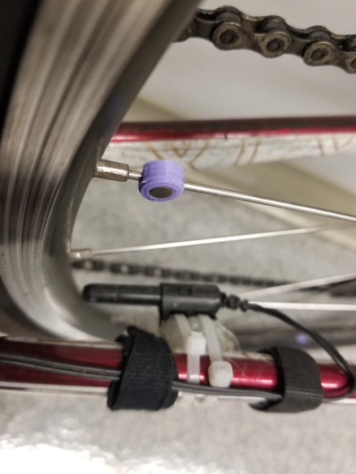

Reed Switch

Magnet